**Objective :**

1. Stateless Widget
2. importing Packages
3. Expended ,row Column

**Class Activity**

**Question 1: Create the Applicating by following these steps**

**Step 1: set up project**

* There is an images folder with all the ball images you will need.
* There are a total of **5** images.

**Step 2: Create Widget and GUI**

* Create a new [**Stateless widget**](https://docs.flutter.io/flutter/widgets/StatelessWidget-class.html) called BallPage in your **main.dart** file.
* Replace the word null with the new **Stateless Widget** you created.

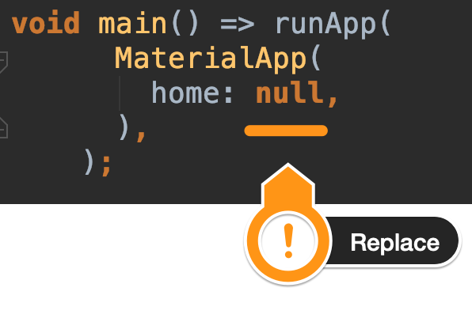

* Your BallPage should have a **Scaffold** with an **AppBar** and an empty **Container** as the body.
* The **AppBar** should have a  **dark** **blue** backgroundColor and a title that says 'Ask Me Anything'.
* The background your Scaffold should have a **blue** color.
* Once you run the app this is what you're aiming for:

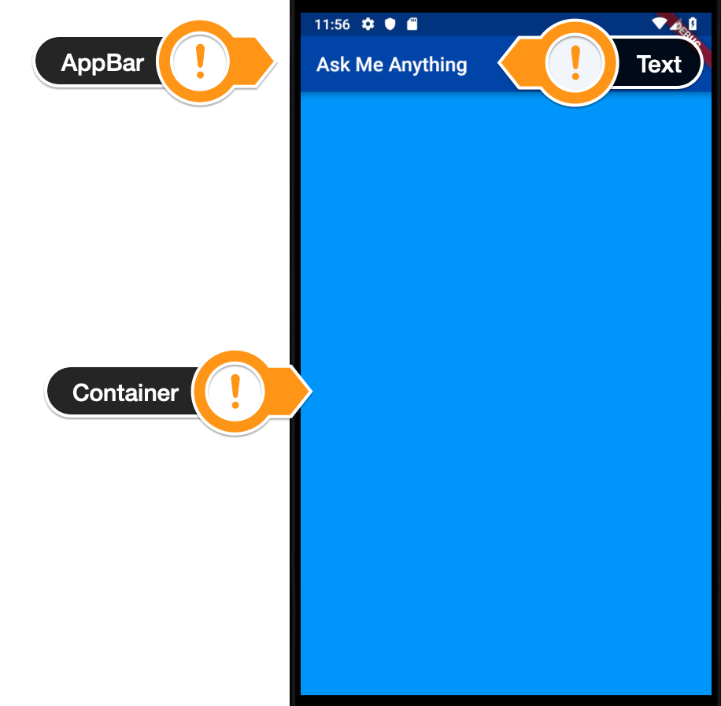

**Step 3: Make it interactive**

* Use a [FlatButton](https://docs.flutter.io/flutter/material/FlatButton-class.html" \t "_blank) Widget to make the Image **clickable**.
* Add a print statement that gets triggered when the button is **pressed**. It should print 'I got clicked'.
* When you **run** the app and click on the ball image you should see the words "I got clicked" into the console like this:
* A screenshot of a cell phone

  Description automatically generated with medium confidence

**Step 4:**

* Add the [dart:math](https://api.dartlang.org/stable/2.2.0/dart-math/dart-math-library.html" \t "_blank) [library](https://api.dartlang.org/stable/2.2.0/dart-math/dart-math-library.html) to your **main.dart** file.
* When the button gets **pressed**, use the Random() generator and the nextInt() method from the dart:math library to generate a new ballNumber between **0 - 4**.
* print the ballNumber to the console when the button gets pressed.
* When you run the app and click on the ball image you should see random number between 0 - 4 printed in the console

**Question no 2: Create Xylophone app Audio playing application**

* Create asset folder with all audio files
* Create 7 Flat Buttons and upon click of each button Audio must be played , GUI of application is given bellow
* Import audio player package in your dart file and use audio Cache methods tp play files in assets

